1. Install Jupyter notebook and run the first program and share the screenshot of the output.

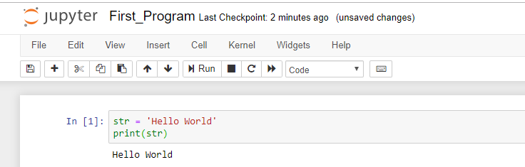

1. Write a program which will find all such numbers which are divisible by 7 but are not a multiple of 5, between 2000 and 3200 (both included). The numbers obtained should be printed in a comma-separated sequence on a single line.

number = []

for i in range(2000, 3200):

if (i%7==0) and (i%5!=0):

number.append(str(i))

print (','.join(number))

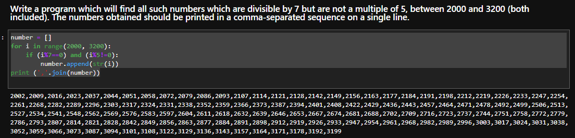

1. Write a Python program to accept the user's first and last name and then getting them printed in the the reverse order with a space between first name and last name.

fname = input('Enter the first name: ')

lname = input('Enter the last name: ')

print('Reverse Order Output: ' + lname + ' ' + fname)

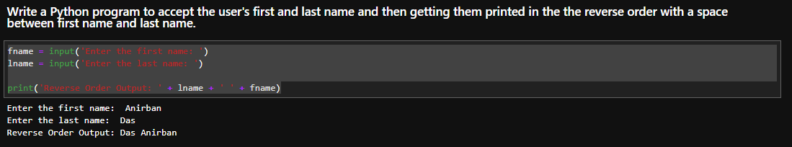

1. Write a Python program to find the volume of a sphere with diameter 12 cm.

Formula: V=4/3 * π * r 3

import math

r = 12

volume = 4/3*math.pi*r**3

print('The volume of the sphere is: ', + volume)

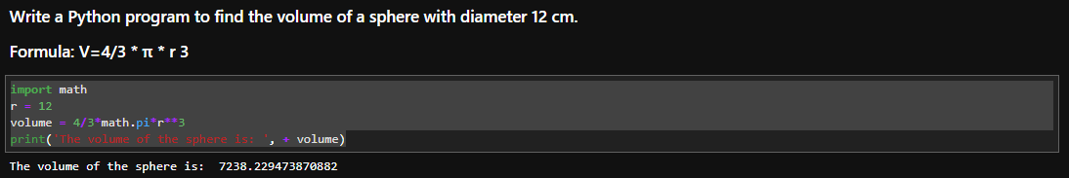

TASK2

1. Write a program which accepts a sequence of comma-separated numbers from console and generate a list.

numlist = []

number = input ('Enter the numbers with separated by comma: ')

numlist = number.split(',')

print(numlist)

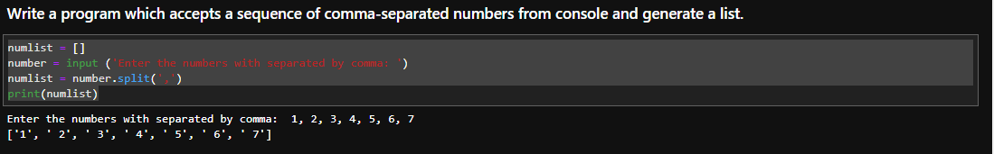

2. Create the below pattern using nested for loop in Python.

*

* *

* * *

* * * *

* * * * *

* * * *

* * *

* *

*

n = 5

for i in range(0, n):

for j in range(0, i+1):

print("* ",end="")

print("\r")

for i in range (n-1, 0, -1):

print(i * '* ' + (n-i) * ' ')

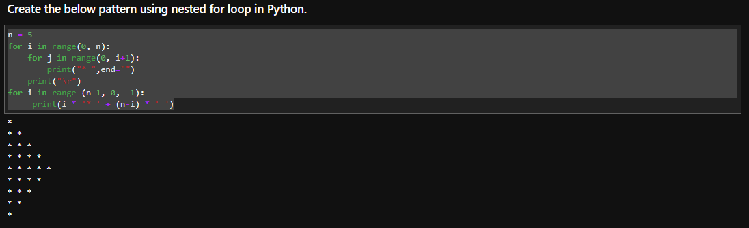

1. Write a Python program to reverse a word after accepting the input from the user.

**Sample Output:**

Input word: AcadGild

Output: dilGdacA

str = input('Enter the word to reverse: ')

strinv = str[::-1]

print(strinv)

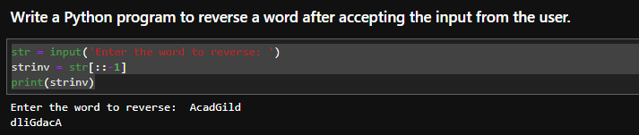

1. Write a Python Program to print the given string in the format specified in the **sample output.**

WE, THE PEOPLE OF INDIA, having solemnly resolved to constitute India into a

SOVEREIGN, SOCIALIST, SECULAR, DEMOCRATIC REPUBLIC and to secure to all

its citizens

**Sample Output:**

WE, THE PEOPLE OF INDIA,

having solemnly resolved to constitute India into a SOVEREIGN, !

SOCIALIST, SECULAR, DEMOCRATIC REPUBLIC

and to secure to all its citizens

print('WE, THE PEOPLE OF INDIA, \n\thaving solemnly resolved to constitute India into a SOVEREIGN, !\n\t\tSOCIALIST, SECULAR, DEMOCRATIC REPUBLIC\n\t\t and to secure to all its citizens'0029

